UID EX 9

AIM:
The aim is to design a modern and visually appealing input form that validates user data such as email and phone number, and displays error messages using HTML, CSS, and JavaScript with Validator.js, incorporating a glassmorphism UI design.

PROCEDURE:

Step 1: Create HTML Form
Create an HTML form with email and phone number fields along with placeholders for error messages.
<!DOCTYPE html>
<html lang="en">
<head>
<meta charset="UTF-8">
<meta name="viewport" content="width=device-width, initial-scale=1.0">
<title>Modern Form Validation</title>
<link rel="stylesheet" href="style.css">
</head>
<body>
<div class="glass-container">
<form id="myForm">
<h2>Register</h2>
<label>Email</label>
<input type="email" id="email" placeholder="Enter your email">
<span id="emailError" class="error"></span>
<label>Phone Number</label>
<input type="text" id="phone" placeholder="Enter phone number">
<span id="phoneError" class="error"></span>
<button type="submit">Submit</button>
</form>
</div>
<script src="https://cdnjs.cloudflare.com/ajax/libs/validator/13.6.0/validator.min.js"></script>
<script src="script.js"></script>
</body>
</html>

Step 2: Styling with Advanced UI (Glassmorphism + Gradient)
body {
margin: 0;
height: 100vh;
font-family: 'Poppins', sans-serif;
background: linear-gradient(135deg, #667eea, #764ba2);
display: flex;
justify-content: center;
align-items: center;
}
.glass-container {
backdrop-filter: blur(15px);
background: rgba(255, 255, 255, 0.1);
padding: 30px;
border-radius: 15px;
width: 300px;
color: white;
box-shadow: 0 8px 32px rgba(0,0,0,0.2);
}
form {
display: flex;
flex-direction: column;
}
input {
padding: 10px;
margin-bottom: 10px;
border: none;
border-radius: 8px;
outline: none;
}
button {
padding: 10px;
border: none;
border-radius: 8px;
background: #00c9a7;
color: white;
cursor: pointer;
transition: 0.3s;
}
button:hover {
background: #00b894;
}
.error {
color: #ff6b6b;
font-size: 0.8em;
}

Step 3: JavaScript Validation
document.getElementById("myForm").addEventListener("submit", function(e) {
e.preventDefault();
let email = document.getElementById("email").value;
let phone = document.getElementById("phone").value;
let emailError = document.getElementById("emailError");
let phoneError = document.getElementById("phoneError");
emailError.textContent = "";
phoneError.textContent = "";
if (!validator.isEmail(email)) {
emailError.textContent = "Enter a valid email address";
}
if (!validator.isMobilePhone(phone, 'any')) {
phoneError.textContent = "Enter a valid phone number";
}
if (validator.isEmail(email) && validator.isMobilePhone(phone, 'any')) {
alert("Form submitted successfully!");
}
});

OUTPUT:
For Valid Input:
- Email and phone number are accepted
- Success message is displayed
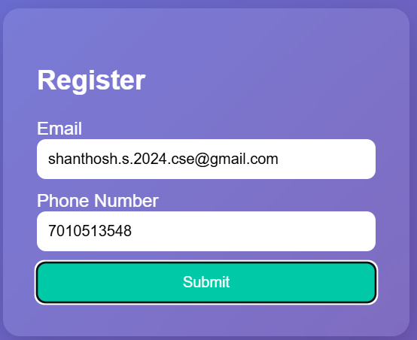

For Invalid Email:
- Error message: "Enter a valid email address"

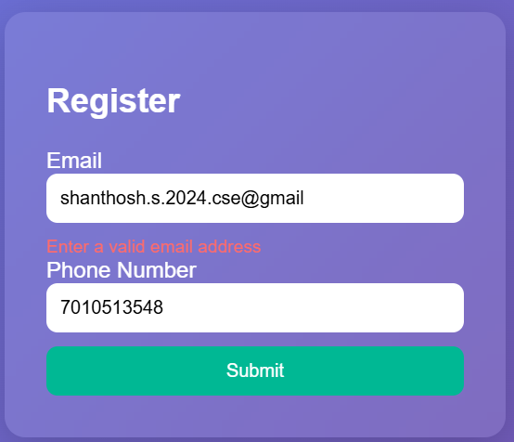
For Invalid Phone Number:
- Error message: "Enter a valid phone number"
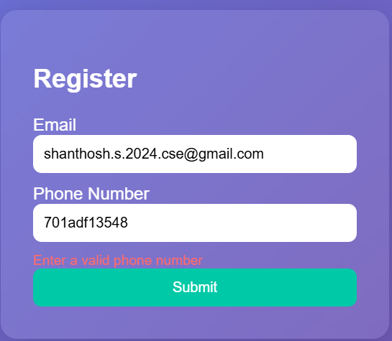

RESULT:
Thus, a modern UI-based form validation system using HTML, CSS (Glassmorphism), and JavaScript with Validator.js was successfully designed and implemented.

